
MOUNT LAWLEY SENIOR HIGH SCHOOL

Semester 2 Examination, 2011

Question/Answer Booklet

MATHEMATICS SPECIALIST
MAS 3C/3D

Section One
Calculator-free

NAME

Time allowed for this section
Reading time before commencing work: 5 minutes
Working time for paper: 50 minutes

Material required/recommended for this section

To be provided by the supervisor
This Question/Answer booklet
Formula sheet

To be provided by the candidate
Standard items: pens, pencils, pencil sharpener, eraser, correction fluid, ruler, highlighters

Special items: nil

Important note to candidates

No other items may be used in this section of the examination. It is your responsibility to ensure that you do not have any unauthorised notes or other items of a non-personal nature in the examination room. If you have any unauthorised material with you, hand it to the supervisor before reading any further.

Structure of this paper

Section | Number of questions available | Number of questions to be answered | Working time (minutes) | Marks available
Section One:  Calculator-free | 6 | 6 | 50 | 40
Section Two:  Calculator-assumed | 13 | 13 | 100 | 80
 |  |  | Total | 120

Instructions to candidates

- The rules for the conduct of Western Australian external examinations are detailed in the Year 12 Information Handbook 2011. Sitting this examination implies that you agree to abide by these rules.

- Write your answers in the spaces provided in this Question/Answer Booklet. Spare pages are included at the end of this booklet. They can be used for planning your responses and/or as additional space if required to continue an answer.
- Planning: If you use the spare pages for planning, indicate this clearly at the top of the page.
- Continuing an answer: If you need to use the space to continue an answer, indicate in the original answer space where the answer is continued, i.e. give the page number. Fill in the number of the question(s) that you are continuing to answer at the top of the page.

- Show all your working clearly. Your working should be in sufficient detail to allow your answers to be checked readily and for marks to be awarded for reasoning. Incorrect answers given without supporting reasoning cannot be allocated any marks. For any question or part question worth more than two marks, valid working or justification is required to receive full marks. If you repeat an answer to any question, ensure that you cancel the answer you do not wish to have marked.

- It is recommended that you do not use pencil, except in diagrams.

Section One: Calculator-free (40 Marks)
This section has six (6) questions.
Answer all questions. Write your answers in the spaces provided.

Working time for this section is 50 minutes.

Question 1 (6 marks)
Consider the function 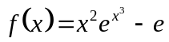.
a) Determine 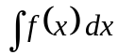. | [1]
The graph of 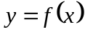 is shown.  b) Carefully shade the area contained between , the lines 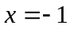, , and 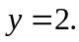 [1] |  | 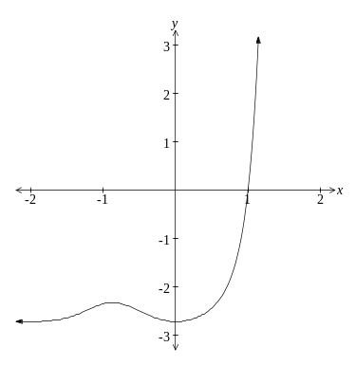
c) Write down an integral whose value represents the shaded area. [1]

d) Prove the shaded area is exactly equal to 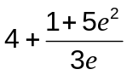. [3]

Question 2 (5 marks)
- Find the equation of the tangent to the curve 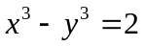 at the point on the curve
where 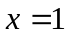. [2]

(b) Evaluate 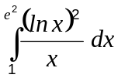. [3]

Question 3 (6 marks)
The transformation matrix 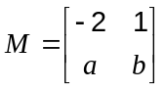.

M represents a shear of factor k parallel to the y-axis followed by a rotation of 90° clockwise.

(a) Use properties of the two transformations to explain why 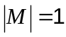 (ie Det M = 1). [1]

(b) Determine the values of a, b and k. [3]

The point P is transformed by M to the point 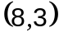.

(c) Determine the coordinates of P. [2]

Question 4 (8 marks)
Consider the identity 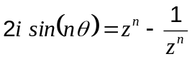 where 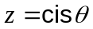.
(a) By initially letting 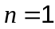, show how to use the identity to prove that:

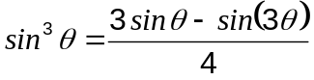. | [5]

Question 4 (continued)

Hence,
(b) evaluate 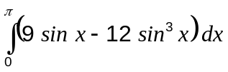. [3]

Question 5 (7 marks)
A minor sector of angle 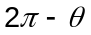 is removed from a circular piece of paper of radius .  The two straight edges of the remaining major sector are pulled together to form a right circular cone, with a slant height of . | 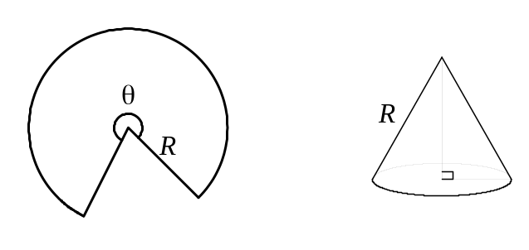

(a) Show that the volume of the cone is given by 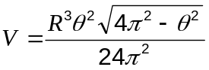. [3]

Question 5 (continued)
Assuming the radius, R, of the circular piece of paper to be fixed,

(b) show the exact value of which maximises the volume of cone is 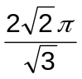. [4]

Question 6 (8 marks)
The Argand diagram below shows the complex number 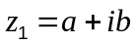 as a position vector
with a and b having integer values.
(a) On the same diagram plot and label the complex numbers 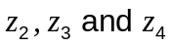 given by:  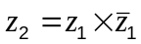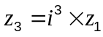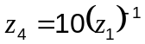 | 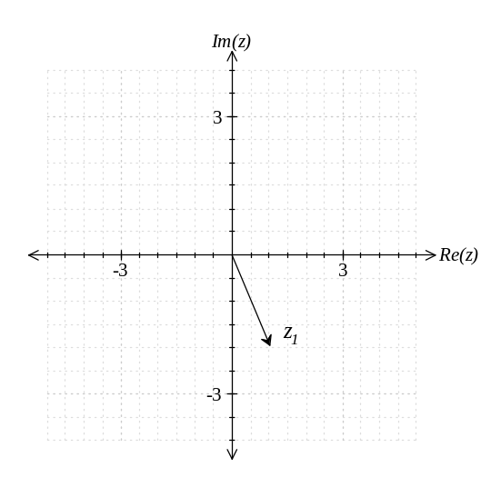  [4]

(b) On the same diagram sketch the region given by 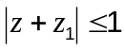. [2]

(c) Determine the Cartesian equation described by 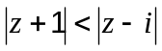. [2]

End of Section One
Additional working space

Additional working space

